
School: ............................................................................................................. Campus: ....................................................... Academic Year: ...................... Subject Name: ........................................................... Subject Code: ..........................
Semester: ............... Program: ........................................ Branch: ......................... Specialization: .......................... Date: .....................................
(Learning by Doing and Discovery)
* Coding Phase: Pseudo Code / Flow Chart / Algorithm
Deploying Your First Solidity Smart Contract on Remix IDE
- Compilation Stage
  - Remix automatically converts your Solidity code into bytecode and ABI — no extra setup needed.
  - The compiler ensures your syntax is valid and matches the chosen version.
  - If there’s even a small syntax error or version mismatch, the build process halts immediately.
- Connecting for Deployment
  - MetaMask serves as the gateway between Remix and the blockchain network (testnet or mainnet).
  - When you click “Deploy,” MetaMask will request your approval, displaying:
• The wallet address initiating the deployment
• Estimated gas consumption and cost
• The network you’re connected to
  - This is where you realize — deploying a contract means broadcasting a blockchain transaction, not just “saving” it somewhere.
- Transaction Execution
  - Once confirmed, you receive a transaction hash, which can be tracked on a blockchain explorer (e.g., Etherscan or Sepolia Explorer).
  - The network processes it, and your contract receives a permanent blockchain address.
  - A gas fee is charged from your MetaMask wallet — even on testnets, where costs are simulated.
- Using the Deployed Contract
  - Remix provides a ready-to-use interface for interacting with your contract functions.
  - Any state-changing action will prompt another MetaMask confirmation.
  - You can observe variable updates, function results, and emitted events directly from the Remix interface.

Coding Phase: Pseudo Code / Flow Chart / Algorithm
Steps to Create and Deploy Your First Solidity Contract in Remix
Step 1: Launch Remix IDE
- Open your browser and go to: https://remix.ethereum.org
Step 2: Start a New Contract File
- On the left panel, open the File Explorer.
- Navigate to the contracts folder.
- Click the "+" icon to create a fresh .sol file (e.g., SimpleStorage.sol).
Step 3: Write Your Solidity Code
pragma solidity ^0.8.0;

contract SimpleStorage {
uint public storedData;

constructor(uint initialValue) {
storedData = initialValue;
}

function set(uint newValue) public {
storedData = newValue;
}

function get() public view returns (uint) {
return storedData;
}
}
Step 4: Compile the Smart Contract
- Go to the Solidity Compiler tab.
- Choose the correct compiler version (0.8.x) and click Compile SimpleStorage.sol.
Step 5: Deploy Your Contract
- Click Deploy and confirm the transaction in MetaMask.
Step 6: Work with Your Contract
- Once deployed, the contract will appear under Deployed Contracts in Remix.
- You can now:
• Click get() → View the stored number.
• Click set(200) → Update the stored number.
• Use storedData() → Automatically retrieve the current value.

* Softwares used
    - Remix IDE
    - MetaMask Wallet

- Testing Phase: Compilation of Code (error detection)
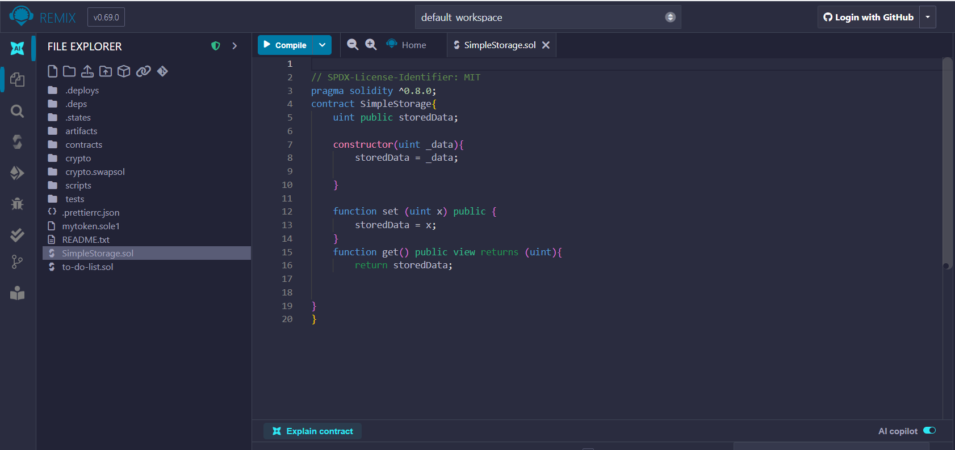
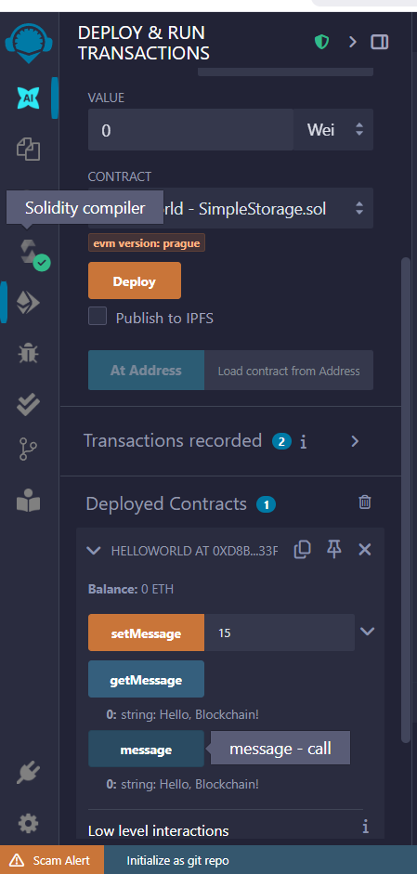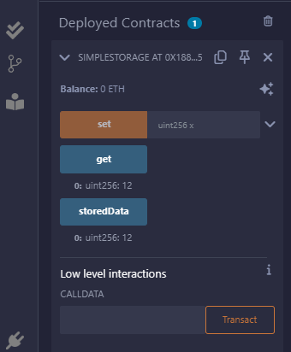

- Implementation Phase: Final Output (no error)

Implementation Phase: Final Output (no error)

- Implementation Phase: Final Output (no error)
Applied and Action Learning

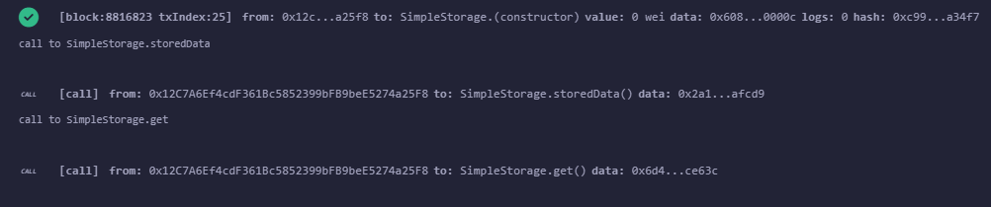

* Observations
- Once a smart contract is on the blockchain, its code cannot be altered — fixing errors means deploying a new version.
- The amount of gas required is influenced by how complex your constructor is and how much storage your contract uses.
- Even the most basic contracts leave a permanent entry on the blockchain and incur gas costs.
- MetaMask serves not only as a crypto wallet but also as the tool that signs and sends your blockchain transactions.

ASSESMENT

Rubrics
Concept | 10
Planning and Execution/  Practical Simulation/ Programming | 10
Result and Interpretation | 10
Record of Applied and Action Learning | 10
Viva | 10
Total | 50


Signature of the Student:
Signature of the Faculty:

